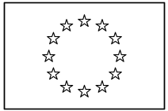 | EUROPEAN COMMISSION  DIRECTORATE-GENERAL  INFORMATICS  Information systems Directorate

European Commission
e-TrustEx Use Case Specification: Submit Document Template

Date: | 10/06/2015
Version: | 1.000
Authors: | Anamaria BATRINU
Revised by: | Technical Review:  Quality Review:
Approved by:
Public:
Reference Number:

TABLE OF CONTENTS
1. Use-Case Description 3
2. References 3
3. Points of Extensions 3
3.1. Points of extension mapping 3
3.2. Document Type Code 4
3.3. Party Roles 4
3.4. Document Identifier 4
3.5. Document Issue Date 4
3.6. Synchronous XSD Validation 4
3.7. Synchronous Schematron Validation 4
3.8. Synchronous Specific Validation 4
3.8.1. Synchronous SLA Validation 4
3.8.2. Other specific validation 5
3.9. Synchronous Business Specific Processing 5
3.10. Asynchronous XSD Validation 5
3.11. Asynchronous Business Rules Validation 5
3.11.1. Asynchronous Schematron Validation 5
3.11.1.1. Hard business rules 5
3.11.1.2. Soft business rules 5
3.11.2. Asynchronous Parent-Child Relationship Validation 5
3.11.3. Reprocessing Timeframe for Parent Document 6
3.11.4. Asynchronous Specific Validation 6
3.12. Asynchronous Business Specific Processing 6
3.12.1. Human Readable Generation 6
3.12.2. SLA Policy Validation 6
3.12.3. Other specific processing 6
3.13. Data Extraction 6
3.14. Availability Notification 7
3.15. State Machine 7
3.15.1. Transition to state Approved 7
3.15.2. Transition to state Rejected 7
3.16. Dispatching 8
4. Additional Information 8
4.1. Message elements 8

Document History

Version | Date | Comment | Modified Pages
1.000 | 10/06/2015 | JIRA ETRUSTEX-1026: Creation based on version 2.005 of the template | All

Use-Case Description
This Use Case describes the service that enables parties to send DocumentBundle document (see section 4.1 Message elements for details about information in the document) via electronic means using the e-TrustEx platform. It extends the generic use case UC1_002 Process Asynchronous Message to DocumentBundle document.

References
Document Title | Document Reference
UC1_002 Process Asynchronous Message | https://webgate.ec.europa.eu/CITnet/svn/ETRUSTEX/trunk/001 e-TrustEx/002 Requirements/Use Case Model/New Use Cases/UC1_002 Process Asynchronous Message.doc
Use Case eTrustex – Submit Application Response | https://webgate.ec.europa.eu/CITnet/svn/ETRUSTEX/trunk/001 e-TrustEx/002 Requirements/Use Case Model/New Use Cases/UC1_003 Submit Application Response Use Case Specification_2.0.doc
DocumentBundle XSD document | https://webgate.ec.europa.eu/CITnet/svn/ETRUSTEX/trunk/001 e-TrustEx/003 Architecture/001 Data Model/200 XSD/xsd/maindoc/EC-DocumentBundleJustice-1.0.xsd
DocumentBundle Schematron rules document | https://webgate.ec.europa.eu/CITnet/svn/ETRUSTEX/trunk/001 e-TrustEx/003 Architecture/001 Data Model/200 XSD/schematron/DocumentBundleJustice/DocumentBundleJustice.sch
Code List Document | https://webgate.ec.europa.eu/CITnet/svn/ETRUSTEX/trunk/001 e-TrustEx/003 Architecture/001 Data Model/000 Code Tables/EC_CodeList_e-TrustEx.xls
Human Readable Template | N/A

Points of Extensions

Points of extension mapping
Point of extension (in this document) | Extended point (in Asynchronous Use Case)
Document Type Code | Point of extension 2  Point of extension 4  Point of extension 9
Party Roles | Point of extension 1
Document Identifier | Point of extension 3
Document Issue Date | Point of extension 8
Synchronous XSD Validation | Point of extension 5
Synchronous Schematron Validation | Point of extension 6
Synchronous Specific Validation | Point of extension 7
Synchronous Business Specific Processing | Point of extension 17
Asynchronous XSD Validation | Point of extension 10
Asynchronous Schematron Validation | Point of extension 11
Asynchronous Parent-Child Relationship Validation | Point of extension 12
Reprocessing Timeframe | Point of extension 16
Asynchronous Specific ValidationError: Reference source not found | Point of extension 18
Data Extraction | Point of extension 13
Asynchronous Business Specific Processing | Point of extension 14
Availability Notification | Point of extension 19
Dispatching | Point of extension 15

Document Type Code
The document type code for DocumentBundle is JUS and it is defined in Code List Document, under the sheet DocumentTypeCode.

Party Roles
The DocumentBundle document must be sent by a Party having Any Role and received by a Party having Any Role.

Document Identifier
The document identifier can be found via the following Xpath expression:
\\DocumentBundle\cbc:ID

Document Issue Date
The document issue date can be found via the following Xpath expression:
\\ DocumentBundle \cbc:IssueDate

Synchronous XSD Validation
N/A

Synchronous Schematron Validation
N/A

Synchronous Specific Validation

Synchronous SLA Validation
The document must be valid according to the following SLA policies:
N/A

Other specific validation
The following rules must be applied during the synchronous validation:
N/A

Synchronous Business Specific Processing
System performs the following synchronous business processing:
- extracts and saves the message correlation id that can be found via the following Xpath expression: \\DocumentBundle\cac:OriginatorDocumentReference\cbc:ID

Asynchronous XSD Validation
The document must be valid according to XSD documentDocumentBundle.

Asynchronous Business Rules Validation

Asynchronous Schematron Validation
The document must be valid according to the following set of rules implemented in the Schematron documentDocumentBundle:

Hard business rules
ID | Description
RULE387 | DocumentBundle.DocumentReference must be unique
RULE492 | UserID cannot be empty.
RULE578 | The ConversationID must be present
RULE579 | DocumentBundle.ReceiverParty.Contact.ID must be present
RULE580 | DocumentBundle.ReceiverParty.PhysicalLocation.CountrySubentityCode must be present

Soft business rules
ID | Description
RULE272 | The DocumentBundle.IssueDate is not in the future
RULE273 | The DocumentBundle.IssueDate is not older than 12 months

Asynchronous Parent-Child Relationship Validation
The parent document, if it exists, must be valid according to the following specific rules which complete the parent-child validation rules described in the asynchronous use case:
ID | Description | Element path | Severity | Category | Subcategory
RULE275/RRC18539 | ParentDocumentID must already exist in the system with the same ParentDocumentTypeCode |  | Hard | External check
RULE290/RRC18534 | The SenderParty of the parent document must be equal to the SenderParty OR ReceiverParty of the document (both found in the header) |  | Hard | External check
RULE291/RRC18529 | The ReceiverParty of the parent document must be equal to the ReceiverParty OR SenderParty of the document (both found in the header). |  | Hard | External check

Reprocessing Timeframe for Parent Document
The reprocessing of the message is done during the following timeframe:
The policy to apply when no parent document is found is ERROR. Thus not reprocessing timeframe is configured.

Asynchronous Specific Validation
The document must be valid according to the following specific rules:
ID | Description
Rule491 | ConversationID (\\DocumentBundle\cac:OriginatorDocumentReference\cbc:ID)  If the ConversationID exists, the UserID (\\DocumentBundle\eccac:UserID) must be the same as the userID of the first message belonging to the conversation.
RULE274/ RRC18533 | DocumentWrapper Reference.ID must point to an existing Document Wrapper (according to the ID and the DocumentTypeCode).  This validation occurs for all the instances of DocumentWrapperReference within the Bundle message
RULE387/ RRC18536 | DocumentWrapperReference must be unique within the message (according to ID and DocumentTypeCode)

Asynchronous Business Specific Processing

Human Readable Generation
N/A

SLA Policy Validation
The message must be valid according to the following SLA policy configurations: the SLA policy is dynamically configurable in the database depending on needs.

Other specific processing
System performs the following specific processing:
System creates a new application response having code JUS:8 and sends it back to the Issuer Party.

Data Extraction
System extracts the following data:
Information to be extracted | Path
User id | //*:DocumentBundle/*:UserID
Title of the conversation | //*:DocumentBundle/*:Title
Business document type of the message | //*:DocumentBundle/*:BusinessDocumentType

Availability Notification
The available notification can be found via the following Xpath expression:
N/A

State Machine
The following state machine shows the usual (generic) states that are Submitted, Received and Error. Beside these states some specific states are displayed in blue: Approved and Rejected.
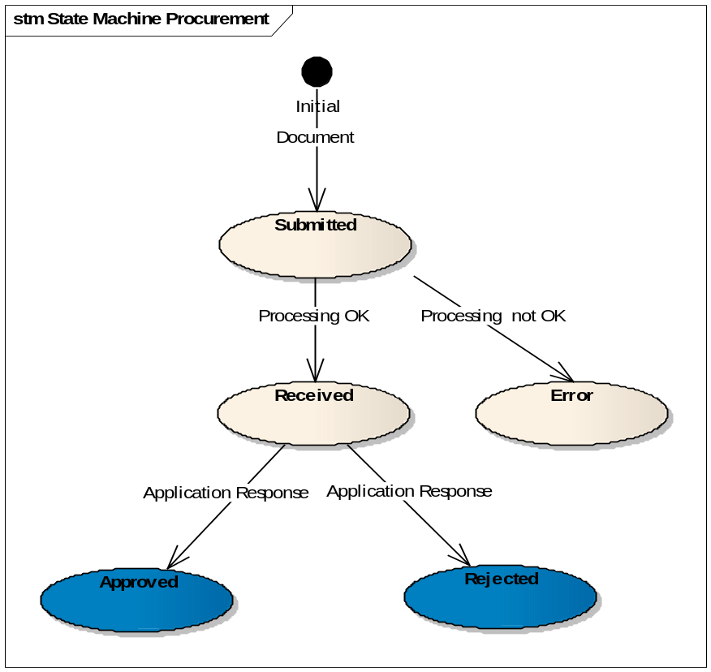

Transition to state Approved
At this point, the Use Case Submit Application Response is included.
When an application response referencing an existing Submit Bundle Justice document in state received arrives in the system with a response code JUS:1 the state of the Submit Bundle Justice document becomes Approved.

Transition to state Rejected
At this point, the Use Case Submit Application Response is included.
When an application response referencing an existing Submit Bundle Justice document in state received arrives in the system with a response code JUS:2 the state of the Submit Bundle Justice document becomes Rejected.

Dispatching
The following routing rules are used for dispatching the message:
The dispatching is configured dynamically in the database depending on needs.

Additional Information

Message elements
Element | Constraint | Xpath
SOAP Header
Sender Identification | Mandatory | Header.BusinessHeader.Sender.Identifier
Receiver Identification | Optional | Header.BusinessHeader.Receiver.Identifier
ID of the message | Optional | Header.BusinessHeader.DocumentIdentification.InstanceIdentifier
Message type | Optional | Header.BusinessHeader.DocumentIdentification.Type
Reply to | Optional | SoapHeader.wsa:ReplyTo.wsa:Address  NOTE: This field should be stored by the system and is available also for the Adapter
SOAP Body
ProfileID | Optional | The ID of the Profile
Bundle ID | Mandatory | DocumentBundle.ID
Issue date of the Bundle | Mandatory | DocumentBundle.IssueDate
Issue time of the Bundle | Optional | DocumentBundle.IssueTime
ConversationID | Mandatory | DocumentBundle.OriginatorDocumentReference.ID
Title of the Conversation | Optional | DocumentBundle.Title
The business type of the document transmitted | Optional | DocumentBundle.BusinessDocumentType
Sender ID | Optional | DocumentBundle.SenderParty.EndpointID
UserID | Mandatory | DocumentBundle.UserID
Receiver ID | Optional | DocumentBundle.ReceiverParty.EndpointID
Receiver Court ID | Optional | DocumentBundle.ReceiverParty.Contact.ID
CountryCode of the Receiver | Optional | DocumentBundle.ReceiverParty.PhysicalLocation.CountrySubentityCode
ID of referenced Document Wrapper | Mandatory | DocumentBundle.DocumentWrapperReference.ID
Document Type Code used for Document Wrapper | Mandatory | DocumentBundle.DocumentWrapperReference.DocumentTypeCode

